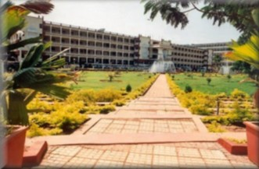

DEPARTMENT OF COMPUTER SCIENCE & ENGINEERING

PRACTICAL COMPONENT OF

Digital Design & Computer Organization

COURSE CODE: BCS302 III SEMESTER

**STUDENT NAME:** YASHAS RAI B L **USN:** 4KV23CS118

**ACADEMIC YEAR:** 2024-25

Course Material Prepared by Course Material Approved by

YASHAS RAI